**DOCUMENT USER GUIDE AND INSTALL**

**SYSTEM MANAGEMENT CERTIFICATE**

**MODULE**

**1.** **Introduction** 2

1.1 ABC Center Certificate. 2

1.2 Member of group two. 2

**2.** **Install Database.** 3

2.1 Overview database. 3

2.2 Setup User login with TCP/IP SQL Server. 3

2.3 Create Database 10

**3.** **Install Software Certificate:** 13

**4.** **How to Management System** 17

4.1 Management Users 17

4.2 Management Student 19

4.3 Management Register of Student 27

4.4 Management Certificate 37

4.5 Management Subjects 44

4.6 Management Exam Mark 49

4.7 Management Certificate Store. 53

4.8 Management User 58

4.9 Management Course 62

4.10 Student Result. 66

4.11 Student Fail. 68

4.12 Change Password 71

4.13 Print Certificate. 73

1. **Introduction**
   1. ABC Center Certificate.

ABC Center Certificate is a center works for the "ABC" institute to developing the certification system for the students who have completed the exam. For each student who goes to the “ABC” institute for register.

The center has a lot of certificates. For example, English Certificate includes A, B, C, and TOIEC…

ABC Center Certificate's main missions are providing regular contests for students. Students can register in the ministry room but before that student can find out about the information the certificate, they want to the registry like Certificate ID, all subjects they must pass to receive the certificate. After learning about information, the student receives student ID this ID will be confidential, so it won’t be exposed to protect the information of the student. But if student ID has been lost or deletes it still can recuperate because all the information always saves on the database of the center.

* 1. Member of group two.

|  |  |  |
| --- | --- | --- |
| **Members** | **Role and Responsibilities** | **Contact** |
| Nghi  Dang Quang | Leader/Analyst/ Designer/ Developer/Tester/ Implementation | dqnghia18086@cusc.ctu.edu.vn |
| Khanh  Nguyen Le | Analyst/Developer/ Tester/ Implementation/ | nlkhanha18083@cusc.ctu.edu.vn |
| Thang  To Toan | Analyst/Designer/  Developer/ Tester | ttthanga18075@cusc.ctu.edu.vn |
| Thanh  Nguyen Phuoc | Analyst/Developer/ Tester/ Implementation/ | npthanha18141@cusc.ctu.edu.vn |

1. **Install Database.**
   1. Overview database.

The Database is a collection of interrelated data where data can be easily accessed, managed and updated. For example, consider ABC institute maintains details of the student such as the name of the student, age, address, class, etc. These all records are related to student stored in a database.

The Database management System is a collection of data and a set of programs to access the data. It allows creation, definition, manipulation of the database. DBMS provides protection and security to the database. Some examples for popular DBMS are MySQL, Oracle, Sybase, Microsoft Access and IBM DB2. But this System just runs only on SQL Server.

* 1. Setup User login with TCP/IP SQL Server.
     1. Reset SQL password
* Step 1: Login into SQL Server

Figure 2.1: Login SQL Server

* A screenshot of a cell phone

  Description automatically generatedStep 2: In Object Explorer, open a Security folder and open a Logins folder. Right-click on 'SA' account and go to Properties.

Figure 2.2: Properties account “SA”

* A screenshot of a social media post

  Description automatically generatedStep 3: Change a 'SA' password and confirm it. Click OK.

Figure 2.3: Change password SQL server

* + 1. Configuration SQL server
* Step 1: On Start menu click mouse right the choose Computer Management.

Figure 2.1: Choose Computer Management

* Step 2: In the interface of computer management select Server and Application. Then you should select a Server and Application continue to select SQL Server activate.

Figure 2.2: Back group of Computer Management

Figure 2.3: Configuration SQL Server Services

* Step 3: Stay at Service and Applications select Protocol for MSSQL SERVER

Figure 2.4: Configuration TCP/IP

* A screenshot of a social media post

  Description automatically generatedStep 4: Select Protocol and continue to choose “Yes” and then click the button “APPLY” and finally click the button “OK”.

Figure 2.5: Configuration of Properties Protocol

* A screenshot of a social media post

  Description automatically generatedStep 5: Select IP Address and continue choose “Yes” (Same Figure 2.6).

Figure 2.6: Configuration of Properties IP Address

* + 1. Create User SQL Login
* A screenshot of a cell phone

  Description automatically generatedStep1: On Start menu select Microsoft SQL Server Management.

*Figure 2.7: Select Microsoft SQL Server Management*

* Step 2: Display form connect to server.

Enter login and password continue to click the button “CONNECT” (same figure 2.8).

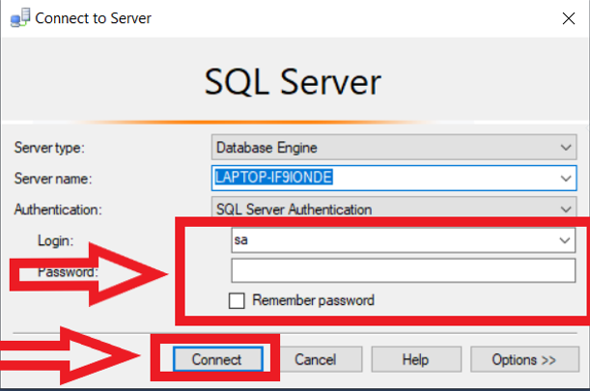After connecting to server successful display back group of SQL Server (same figure 2.9).

Figure 2.8: Connect to SQL Server

Figure 2.9: Back group of SQL Server

* 1. 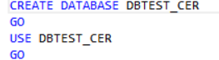A screenshot of a cell phone

     Description automatically generatedCreate Database

Figure 2.10: Example code create database

* + 1. 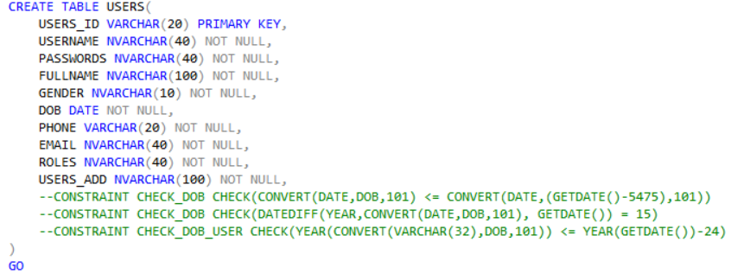Create Table, Constant

Figure 2.11: Example code create table, constant

* + 1. 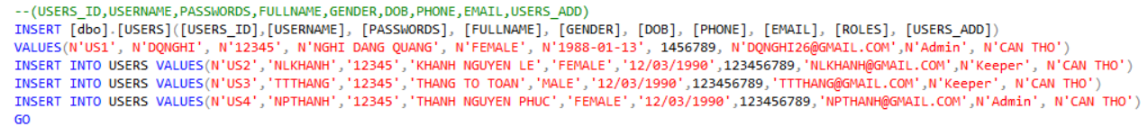Insert Table

Figure 2.12: Example code insert table

* + 1. 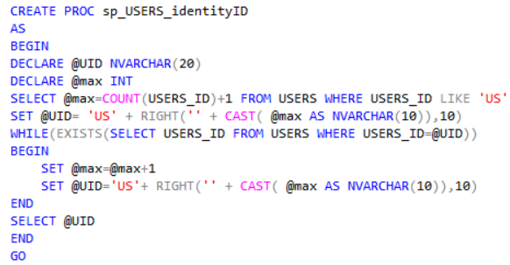Create PROC

Figure 2.13: Example code create PROC

* + 1. Update Table, Column

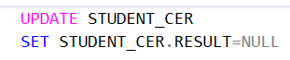

Figure 2.14: Example code update table, column

* + 1. Delete Table, Column



Figure 2.15: Example code delete table, column

* Open files 

And then CTRL + A and press key F5 or choose 

* Restore a database on SQL Server using *.mdf, *.ldf and *.ndf files.

**Using Enterprise Manager**:

* Expand the registered SQL server
* Right-click Databases, select All Tasks -> Attach Database...
* Click the "..." button to browse for the *.mdf file
* Highlight the necessary *.mdf file and click OK
* Click OK again
* The database will now show up in Enterprise Manager

OR

* detach the database (right click the database and click Detach)
* copy the *.mdf and *.ldf files to your backup location
* attach the database (right click Databases and click Attach)

**This is the path where you will find MDF file:**

C:\Program Files\Microsoft SQL Server\MSSQL13.SQLEXPRESS\MSSQL\DATA

* Backup database
  + Open SQL Server Management Studio Express and connect to the SQL server.
  + Expand **Databases**.
  + Right-click on the database you want to back up, then select **Tasks > Back up**. (This is not available for version 2018/2019)
  + On the Back up Database window, make sure the **Database**field contains the name of the database you want to back up.
  + Select the **Backup Type**. By default, it is **Full**- leave it set to that.
  + Click **Remove**to remove the default/last backup file name.
  + Click **Add**to open the Select Backup Destination window.
  + Click **[...]**next to the File Name field.
  + On the Locate Database Files window, select the folder where you want to backup file to go. By default, it is **...\Microsoft SQL Server\MSSQL.1\MSSQL\Backup**.
  + In the **File Name** field, type the name for this backup, with a \***.bak**extension. For example, **xyz_20080221.bak** for a backup of the XYZ database created on 21 February 2008.
  + Click **OK** to close the Locate Database Files window.
  + Click **OK** to close the Select Backup Destination window.
  + Click **OK**to start the backup. The progress icon displays in the lower left corner, and a ‘completed successfully’ message displays when it’s done.

1. **Install Software Certificate:**

* **Step 1: Download file setup**

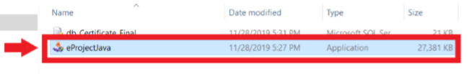

Figure 3.1: Click on file “eProjectJava.exe”

* **Step 2: Install file setup.**

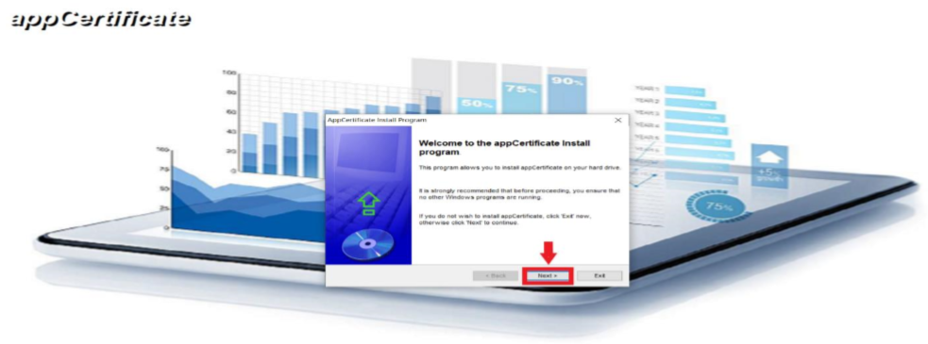

Figure 3.2: Step 2.1 After Step 1 of installing the setup and click the button “Next” 2 times

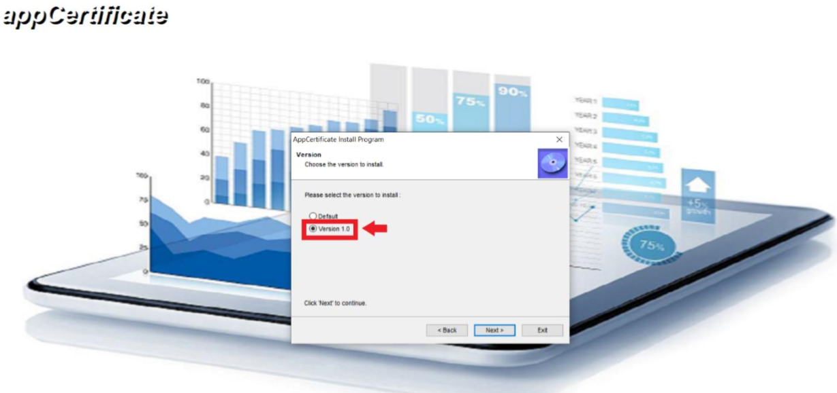

*Figure 3.3: Step 2.2 of installing the setup choose “Version 1.0” and click the button “Next”*

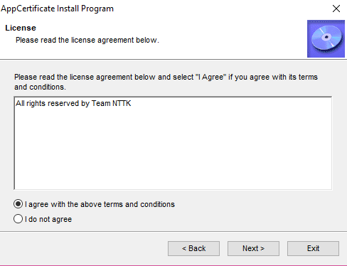

*Figure 3.4: Step 2.3 of installing the setup choose “I agree” and click the button “Next”*

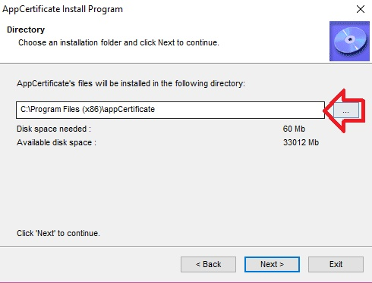

*Figure 3.5: Step 2.4 of installing the setup choose file save and click the button “Next”*

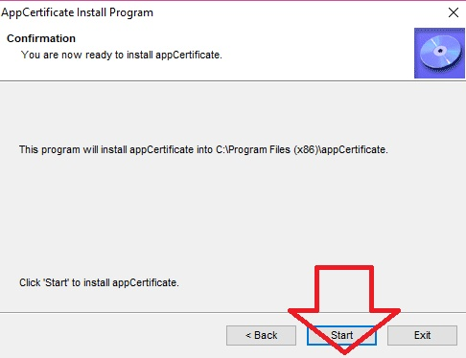

*Figure 3.6: Step 2.5 of installing the setup and Click the button “Start”*

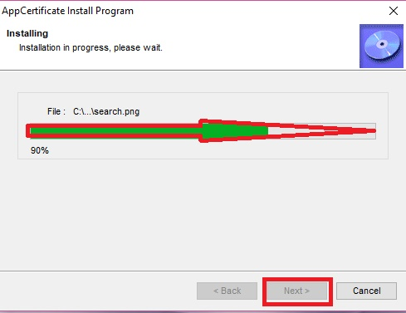

*Figure 3.7: Step 2.6 of installing the setup and load application, click the button “Next”, and then click the button “Exit”*

* **Step 3: Open the saved folder during installation**

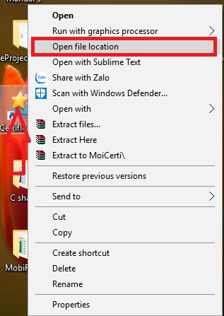

*Figure 3.8: On desktop have an icon “CertificateBC” click-right and then choose Open file location*

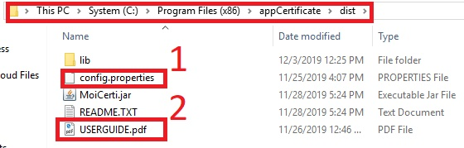

*Figure 3.9: checking in folder “dist” have two files include (config.properties and USERGUIDE.pdf)*

**\*\*\*Notes:**if a folder “dist” have not some files here. You must back to folder “appCertificate” and then copy two files here to folder “dist”.

1. **How to Management System**
   1. Management Users

* A screenshot of a cell phone

  Description automatically generatedStep 1: Login connection with Database.

Figure 4.1: Form connect to Database

Figure 4.2: Form connect to database success

* Step 2: Login username and password

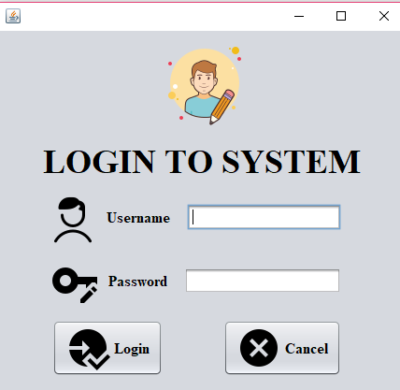

Figure 4.3: Form login to system

* A screenshot of a cell phone

  Description automatically generatedStep 3: Form system management certificate.

Figure 4.4: Form main of system management certificate

* 1. Management Student
* A screenshot of a cell phone

  Description automatically generatedStep 1: In form system management certificate. Click the button “Management Student”

Figure 4.5: Click the button “Management Student”

* Step 2: Display Form Management Student

Figure 4.6: Back group form “Management”

* A screenshot of a cell phone

  Description automatically generatedStep 3: User want add information student

Figure 4.7: Click the button “Add” in Management Student

After clicking the button “Add”. Enter information student and clicking the button “Save” and then the information of the student will display in the Table View.

Figure 4.8: After clicking the button “Add”

* Step 4: A User wants to edit information students

Figure 4.9: Click the button “Edit” in Management Student

After clicking the button “Edit”. Enter information students want to edit and click the button “Save”. And display notifies.

Figure 4.10: After clicking the button “Edit” in Management Student

* A screenshot of a cell phone

  Description automatically generatedStep 5: A User wants to delete information students.A screenshot of a cell phone

  Description automatically generated

Figure 4.11: Click the button “Delete” in management student

After clicking the button “Delete”. Display a message.

Click the button “OK” in a message.

Figure 4.12: After clicking the button “Delete” in management student

* A screenshot of a cell phone

  Description automatically generatedStep 6: A User wants to report information students.

Figure 4.13: Clicking the button “Report” in management students

After clicking the button “Report” and then display form report. Choosing a folder saves and enter a name which you want to save. And finally, click the button “Save”

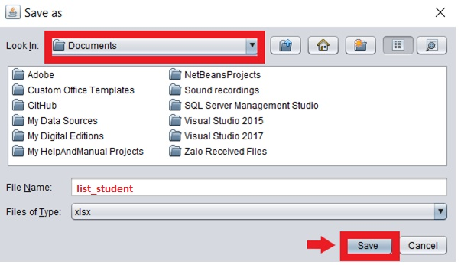

Figure 4.14: Report file list_student.elsx

* Step 7: User want close form.

Click the button “Close” and back to form management main.

Figure 4.16: Back to form System Management Certificate

Figure 4.15: Click the button “Close” in management student

* 1. Management Register of Student
* 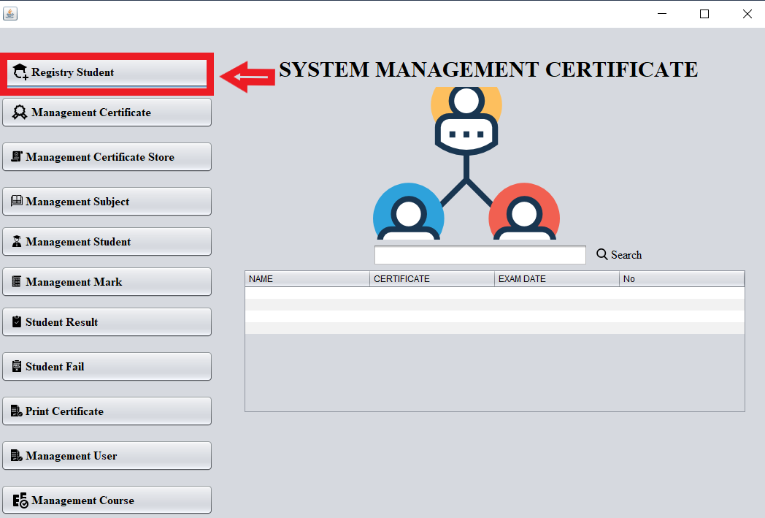Step 1: In form system management certificate. Click the button “Management Register Student”.

Figure 4.17: Click the button “Registry student”

* 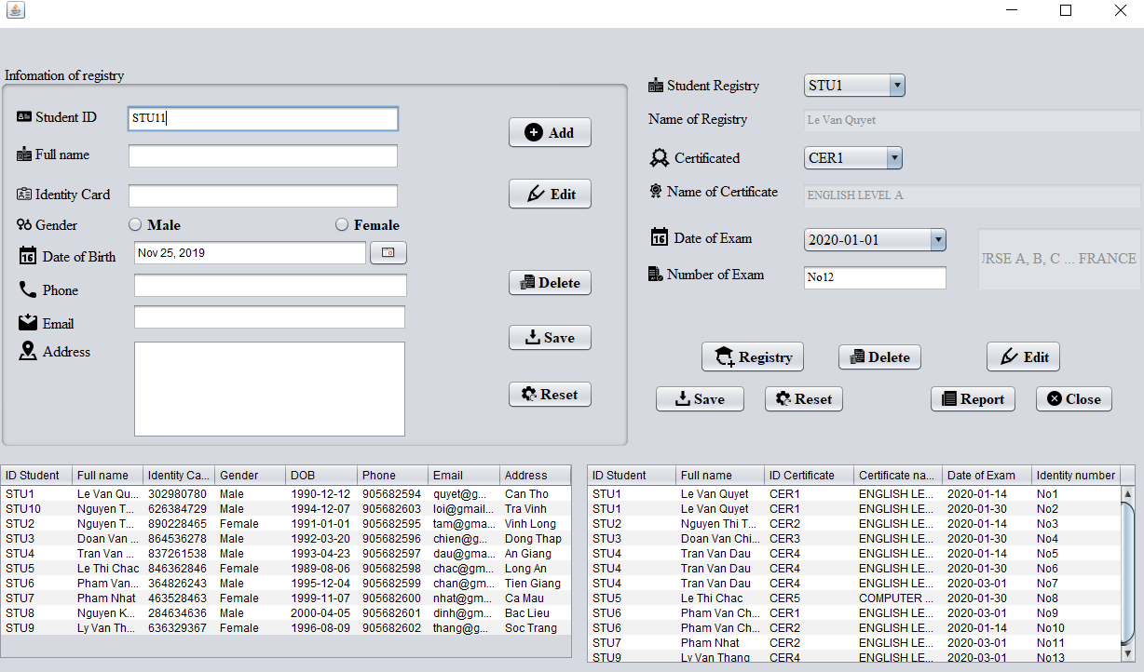Step 2: Display form Register Student.

Figure 4.18: Form Register Student

* A screenshot of a computer

  Description automatically generatedStep 3: A User wants to add information students

Figure 4.19: Click the button “Add” in registry student

After clicking the button “add”. Enter the information of the students and click the button “save”. (THE SAME STEP 3 – 4.2)

* A screenshot of a computer

  Description automatically generatedStep 4: A User wants to edit information students

Figure 4.20: Click the button “Edit” in registry student

After clicking the button “Edit” and choose information student and enter information student be edit and click the button “Save”. (THE SAME STEP 4 - 4.2)

* Step 5: A User wants to delete information students

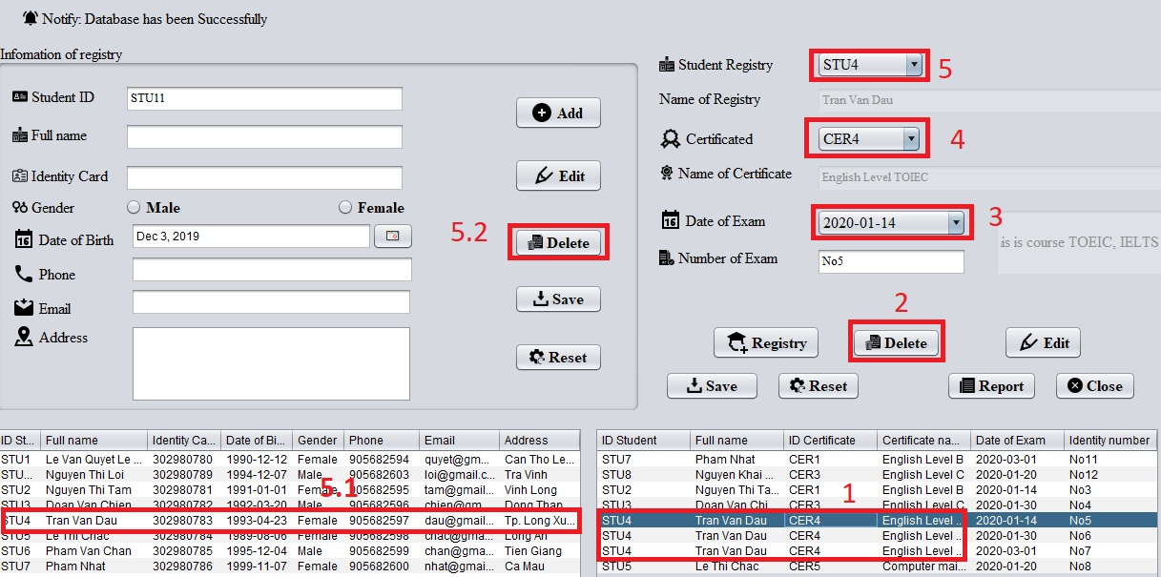

Figure 4.21: Click the button “Delete” in registry student

After clicking the button “Delete” and choose information students have registered and then display a message and click “OK”. If the certificate, student, and course have a certificate ID (4), student ID (5), exam date (3) each to an identity number (1). Else you must delete that certificates, students (5.1, 5.2), and courses each to an identity number (1).

* A screenshot of a computer

  Description automatically generatedStep 6: User want report information student

Figure 4.22: Click the button “Report” in registry student

After clicking the button “Report”. Display form report. Choose folder save, enter name. And click the button “Save”.

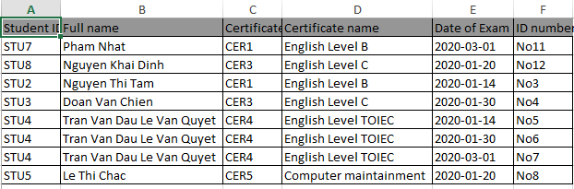*Figure 4.22: Result of registry the students*

* Step 7: A User wants to register for a student.

Figure 4.23: Click the button “Registry” in registry student

After clicking the button “Registry”. And choose to combo box “Student Registry”, “Certificated” and “Date of Exam”. And click the button “Save”.

Figure 4.24: After clicking the button “registry” in registry student

* A screenshot of a computer

  Description automatically generatedStep 8: A User wants to edit information register for a students.

Figure 4.25: Click the button “Edit” in registry student

* Step 9: A User wants to delete information register for student.

After clicking the button “Delete” and a choose information students want to delete on Table View and then display message, click the button “OK”. If the certificate, student, and course have a certificate ID (4), student ID (5), exam date (3) each to an identity number. (Review to Step 5).

Figure 4.26: Click the button “Delete” in registry student

* A screenshot of a computer

  Description automatically generatedStep 10: User want report information register for student. (THE SAME STEP 6 – 4.2).

Figure 4.27: Click the button “Report” in registry student

* A screenshot of a computer

  Description automatically generatedStep 11: A User wants to close form. (THE SAME STEP 7 – 4.2).

Figure 4.28: Click the button “Close” in registry student

* 1. Management Certificate
* A screenshot of a cell phone

  Description automatically generatedStep 1: In form system management certificate. Click the button “Management Certificate”.

Figure 4.29: Click the button “Management Certificate”

* A screenshot of a cell phone

  Description automatically generatedStep 2: Display Form Management Certificate.

Figure 4.30: Form Management certificate

* A screenshot of a cell phone

  Description automatically generatedStep 3: User want to add certificate. (SAME a STEP 3-4.2).

Figure 4.31: Click the button “Add” in management certificate

* A screenshot of a cell phone

  Description automatically generatedStep 4: User want edit certificate. (THE SAME STEP 4 -4.2).

Figure 4.32: Click the button “Edit” in management certificate

* A screenshot of a cell phone

  Description automatically generatedStep 5: User want to delete certificate. (SAME a STEP 5 -4.2).

Figure 4.33: Click the button “Delete” in management certificate

* A screenshot of a cell phone

  Description automatically generatedStep 6: User want report certificate. (SAME a STEP 6 -4.2).

Figure 4.34: Click the button “Report” in management certificate

* A screenshot of a cell phone

  Description automatically generatedStep 7: User want close form. (THE SAME STEP 7-4.2).

Figure 4.35: Click the button “Close” in management certificate

* 1. Management Subjects
* A screenshot of a cell phone

  Description automatically generatedStep 1: In form system management certificate. Click the button “Management Subject”.

Figure 4.36: Click the button “Management Subject”

* A screenshot of a cell phone

  Description automatically generatedStep 2: Display Form Management Subject.

Figure 4.37: Form Management subject

* A screenshot of a social media post

  Description automatically generatedStep 3: A User wants to add subject. (SAME a STEP 3 – 4.2).

Figure 4.38: Click the button “Add” in management subject

* A screenshot of a social media post

  Description automatically generatedStep 4: A User wants to edit subject. (SAME a STEP 4 – 4.2).

Figure 4.39: Click the button “Edit” in management subject

* A screenshot of a social media post

  Description automatically generatedStep 5: A User wants to delete subject. (SAME a STEP 5 – 4.2)

Figure 4.40: Click the button “Delete” in management subject

* A screenshot of a social media post

  Description automatically generatedA screenshot of a social media post

  Description automatically generatedStep 6: A User wants to report subject. (THE SAME STEP 6 – 4.2).

Figure 442: Click the button “Close” in management subject.

Figure 4.41: Click the button “Report” in management subject

* Step 7: User want close form. (THE SAME STEP 7 – 4.2).
  1. Management Exam Mark
* A screenshot of a cell phone

  Description automatically generatedStep 1: In form system management certificate. Click the button “Management Mark”.

Figure 4.43: Click the button “Management Mark”

* A screenshot of a cell phone

  Description automatically generatedStep 2: Display Form “Management Mark”.

Figure 4.44: Form Management Mark

* A screenshot of a cell phone

  Description automatically generatedStep 3: A User wants to add mark (THE SAME STEP 3 – 4.2).

Figure 4.45: Click the button “Add” in management mark

Step 4: A User wants to edit mark (THE SAME STEP 4 – 4.2).

Figure 4.46: Click the button “Edit” in management mark

Step 5: A User wants to delete mark (THE SAME STEP 5 – 4.2)

Figure 4.47: Click the button “Delete” in management mark

Step 6: A User wants to report mark (THE SAME STEP 6 – 4.2).

Figure 4.48: Click the button “Report” in management mark

Step 7: A User wants to close form (SAME a STEP 7 – 4.2).

Figure 4.49: Click the button “close” in management mark

* 1. Management Certificate Store.
* A screenshot of a cell phone

  Description automatically generatedStep 1: In form system management certificate. Click the button “Management Certificate Store”.

Figure 4.50: Click the button “Management Certificate Store”

* A screenshot of a social media post

  Description automatically generatedStep 2: Display form Management Certificate Store.

Figure 4.51: Form Management Certificate Store

* A screenshot of a social media post

  Description automatically generatedStep 3: A User wants to add Certificate Store (THE SAME STEP 3 – 4.2).

Figure 4.52: Click the button “add” in Management Certificate Store

* A screenshot of a social media post

  Description automatically generatedStep 4: A User wants to edit Certificate Store (THE SAME STEP 4 – 4.2).

Figure 4.53: Click the button “edit” in Management Certificate Store

* Step 5: A User wants to delete Certificate Store (THE SAME STEP 5 – 4.2).

Figure 4.54: Click the button “delete” in Management Certificate Store

* A screenshot of a social media post

  Description automatically generatedStep 6: A user wants to report Certificate Store (THE SAME STEP 6 – 4.2).

Figure 4.55: Click the button “report” in Management Certificate Store

* A screenshot of a social media post

  Description automatically generatedStep 7: A user wants to close form (THE SAME STEP 3 – 4.2).

Figure 4.56: Click the button “close” in Management Certificate Store

* 1. Management User
     + A screenshot of a cell phone

       Description automatically generatedStep 1: In form system management certificate. Click the button “Management User”.

Figure 4.57: Click the button “Management User”

* + - A screenshot of a social media post

      Description automatically generatedStep 2: Display form Management User.

Figure 4.58: Form Management User

* + - A screenshot of a social media post

      Description automatically generatedStep 3: A user wants to add information user (THE SAME STEP 3 – 4.2).

Figure 4.59: Click the button “add” in Management User

* + - A screenshot of a social media post

      Description automatically generatedStep 4: A user wants to edit information user (THE SAME STEP 4 – 4.2).

Figure 4.60: Click the button “edit” in Management User

* + - Step 5: A user wants to delete information user (THE SAME STEP 5 – 4.2).

Figure 4.61: Click the button “delete” in Management User

* + - A screenshot of a social media post

      Description automatically generatedStep 6: A user wants to close a form (THE SAME STEP 7 – 4.2).

Figure 4.62: Click the button “close” in Management User

* 1. Management Course
* A screenshot of a cell phone

  Description automatically generatedStep 1: In form system management certificate. Click the button “Management Course”.

Figure 4.63: Click the button “Management Course”

* Step 2: Display form Management Course.

Figure 4.64: Form Management Course

* A screenshot of a social media post

  Description automatically generatedStep 3: A user wants to add information course (THE SAME STEP 3 – 4.2).

Figure 4.65: Click the button “add” in Management Course

* A screenshot of a social media post

  Description automatically generatedStep 4: A user wants to edit information courses (THE SAME STEP 4 – 4.2).

Figure 4.66: Click the button “edit” in Management Course

* A screenshot of a social media post

  Description automatically generatedStep 5: A user wants to delete information courses (THE SAME STEP 5 – 4.2).

Figure 4.67: Click the button “delete” in Management Courses

* A screenshot of a cell phone

  Description automatically generatedStep 6: A user wants to report information courses (THE SAME STEP 6 – 4.2).

Figure 4.68: Click the button “report” in Management Course

* Step 7: A user wants to form (THE SAME STEP 3 – 4.2).

Figure 4.69: Click the button “close” in Management Course

* 1. Student Result.
* A screenshot of a cell phone

  Description automatically generatedStep 1: In form system management certificate. Click the button “Student Result”.

Figure 4.70: Click the button “Student Result”

* A screenshot of a cell phone

  Description automatically generatedStep 2: Display form of Student Result

Figure 4.71: Form Student Result

* A screenshot of a cell phone

  Description automatically generatedStep 3: A user wants to report Student Result

Figure 4.72: Click the button “Report” in Student result

After clicking the button “Report”

Figure 4.73: After clicking the button “Report”

* A screenshot of a cell phone

  Description automatically generatedStep 4: A user wants to close a form of Student Pass.

Figure 4.74: Click the button “close” in student result

* 1. Student Fail.
* A screenshot of a cell phone

  Description automatically generatedStep 1: In form system management certificate. Click the button “Student Fail”.

Figure 4.75: Click the button “Student Fail”

* A screenshot of a cell phone

  Description automatically generatedStep 2: Display form Student Fail.

Figure 4.76: Form Student Fail

* A screenshot of a cell phone

  Description automatically generatedStep 3: A user wants to report Student Fail.

Figure 4.77: Click the button “Report Student Fail”

After that clicking a button “Report”.

Figure 4.78: After click the button “Report Student Fail”

* A screenshot of a cell phone

  Description automatically generatedStep 4: A user wants to close a form of Student Fail.

Figure 4.79: Click the button “close” in student fail

* 1. Change Password
* A screenshot of a cell phone

  Description automatically generatedStep 1: Click the button “Change Password” in form Management Mark.

Figure 4.80: Click the button “Change Password” in form Management Mark

* A screenshot of a cell phone

  Description automatically generatedStep 2: Select a user wants to change password

Figure 4.81: Select a user wants to change password

* A screenshot of a cell phone

  Description automatically generatedStep 3: Enter current password, new password and Confirm Password. And click the button “Change”.
* Step 4: A user wants to close a change password.

Figure 4.82: Enter Current password, new password, and Confirm Password and then click the button “Change”.

Figure 4.83: Click the button “close” in the change to a password

After clicking the button “close” in change password. Back to form Management Mark.

* 1. Print Certificate.
* A screenshot of a cell phone

  Description automatically generatedStep 1: In form system management certificate. Click the button “Print Certificate”.

Figure 4.84: Click the button “Print Certificate”

* A screenshot of a cell phone

  Description automatically generatedStep 2: Display Form “Print Certificate”.

Figure 4.85: Form Print Certificate

* A screenshot of a cell phone

  Description automatically generatedStep 3: Enter Identity of number in the search to text and click the button “Search” and then display the information certificate of the student.

Figure 4.86: Enter Identity of number in the search text and click the button “Search”

* A screenshot of a cell phone

  Description automatically generatedA screenshot of a cell phone

  Description automatically generatedStep 4: Clicking the button “Exam Result” and then display a form “Student Result”.

Figure 4.87: Clicking the button “Exam Result”. Display form “Student Result”

* Step 5: Display form after clicking the button “Print”. Select a print type and click the button “OK” or “Cancel”.

Figure 4.88: Display form after clicking the button “Print”